Team,
I know that many of you have questions regarding Zoom and how it works. I wanted to sit down and provide some instruction to ease the transition as much as possible.
Basics: Chose a device that has a microphone and camera built in. This can be a laptop, desktop with a webcam, tablet, or even your cellphone. (Note: The IT department has run out of laptops, tablets, and webcams and cannot get any as they are currently on backorder.)
If you are just participating in a meeting, but not hosting the meeting, you will receive a meeting invite via email. That meeting invite will have a zoom link within it which will look like this:

From: Host@hsc.wvu.edu
Date: March 25, 2020 at 12:42:34 PM EDT
To: Participants anywhere in the world
Subject: Zoom Meeting 3/25/2020 @ 10:30am
Team,
We have decided to hold this meeting via zoom to ensure everyone is able to attend. Please copy and paste the following link into your browser. Please let me know if you have any issues.
https://wvumdtv.zoom.us/j/9072896980
Meeting ID: 907 289 6980

You have several options now.
Option 1) Click on the Https: Link.
When clicking on the link you should see a page similar to this:
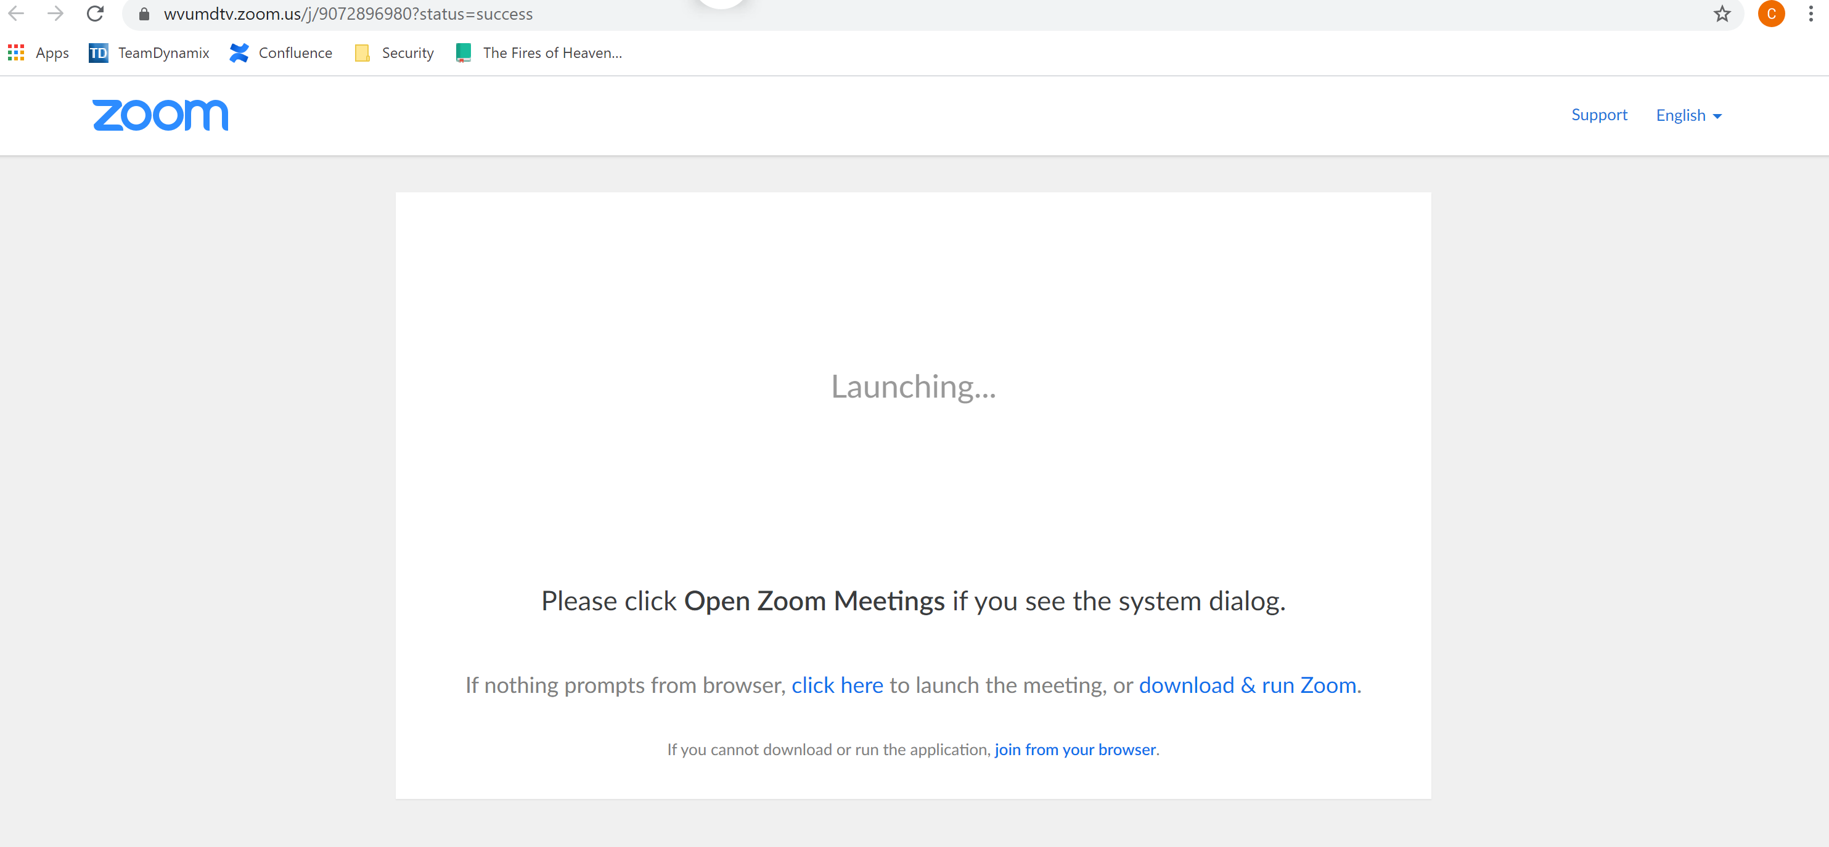
I recommend you “download & run Zoom” your first time. Just click the blue link on the page and follow the standard prompts.
If you don’t see the above page or see something other than the above page, the link was not configured correctly and you should try the next option.

Option 2: Copy and Paste the link
Simply return to the invitation email and copy and paste the link into any browser address bar: https://wvumdtv.zoom.us/j/9072896980 and press enter.
Doing so should redirect you to the following page.

I recommend you “download & run Zoom” your first time. Just click the blue link on the page and follow the standard prompts.

If you don’t see the above page or see something other than the above page, the link was not configured correctly and you should try the next option.

Option 3) Join using the Meeting ID.
Open a browser and navigate to ZOOM.COM
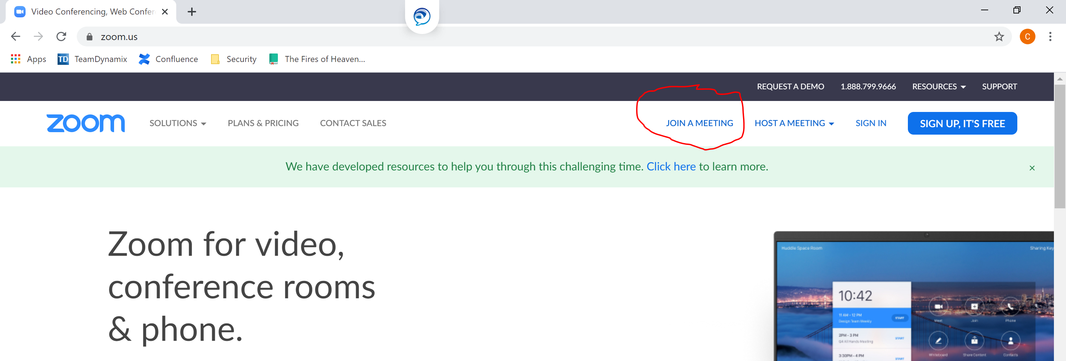
Click JOIN MEETING, then enter the meeting id provided in the invitation email.
That page should look like this:
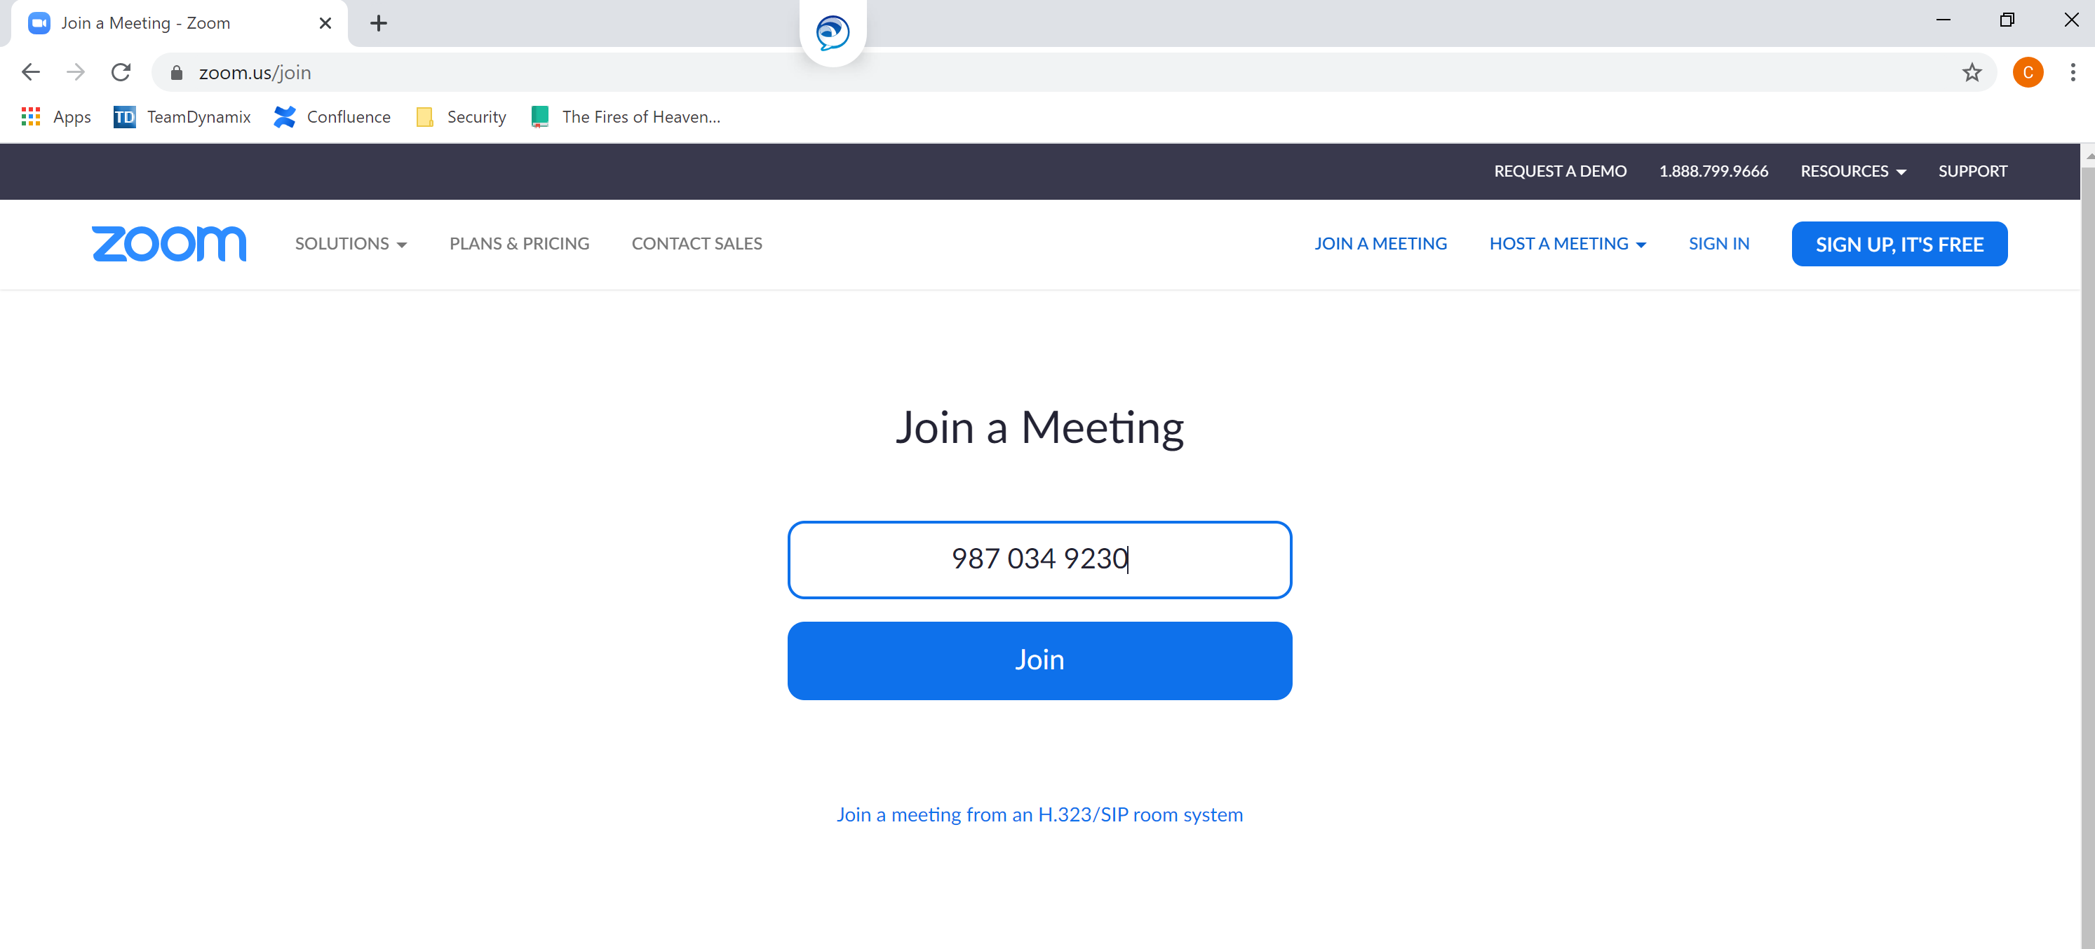

This will redirect you to the meeting. You will be given another opportunity to install and launch zoom. I recommend Installing and running zoom.

Are you hosting the meeting?
You need to follow these instructions to get set up:
- The first step is to request an account through MDTV:
Go to the ITS website. https://its.hsc.wvu.edu/
Under the Sole tab click on the HSC Contingency Planning and Preparedness line.
Under the Remote Lecture and Video Capture at HSC section and click on the MDTV line and email us this way.
Or have them call or email Cindy Barnes at cbarnes@hsc.wvu.edu or 304-293-1418 and she can take care of it.
The confirmation email will look as follows:
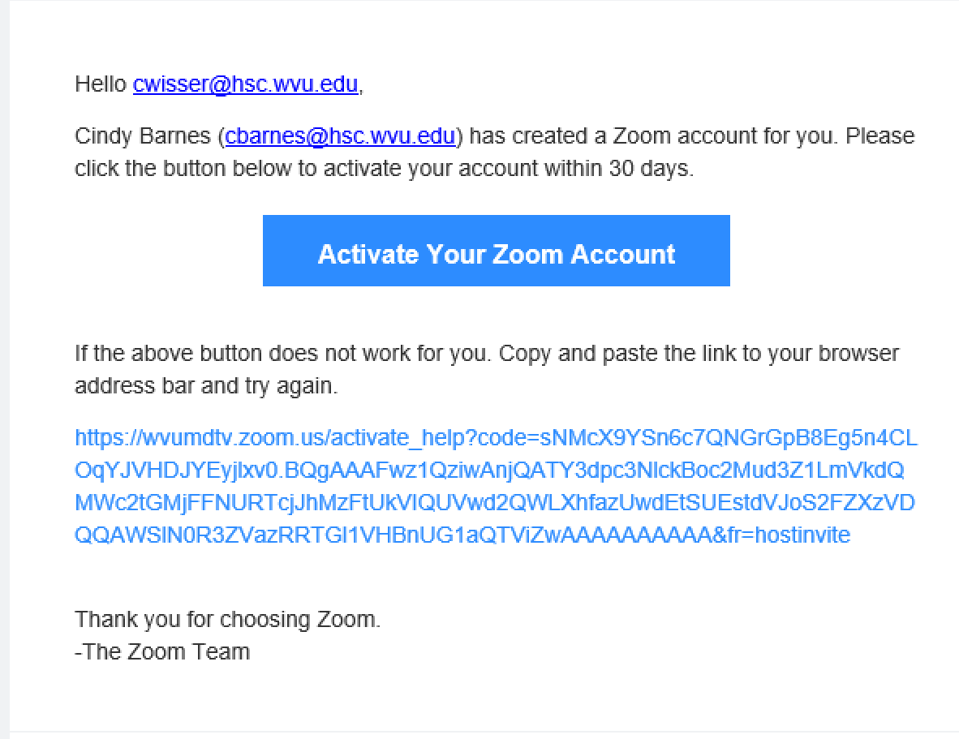
Once you have received confirmation that your account has been set up and you have activated your Zoom account, you need to download Zoom onto your device (pc, mac, tablet, or cellphone) I recommend that you chose a device that has a built in camera and microphone.
You can do so by doing any of the following:
PC/MAC: Go to https://zoom.us/download and from the Download Center, click on the Download button under “Zoom Client For Meetings”. This application will automatically download when you start your first Zoom Meeting.
Tablest and Cellphones Zoom mobile app: You can download the Zoom mobile app for your iOS or Android device from the Apple App Store or the Google Play Store .

Once you have installed the app, simply launch it from your device. Log in. And schedule your meeting. After scheduling the meeting you will be provided with a meeting ID and link which you will need to email to each participant.
Detailed instruction and video can be found here: https://support.zoom.us/hc/en-us/articles/201362413-Scheduling-meetings

