CLASS of 2026 FACTS & FIGURES

(Incoming Class of 2022)
Undergraduate Degrees Represented
Class Overview

 | Applicants |  | Enrollees
Total | 946 |  | 48
Resident | 55 | 6% | 31 | 65%
Non- Resident | 891 | 94% | 17 | 35%
Men | 472 | 50% | 27 | 56%
Women | 473 | 50% | 21 | 44%
* One Non-resident applicant did not report gender
Biochemistry | 3
Biology | 30
Biological Science | 1
Biomedical Laboratory Diagnostics | 1
Cell, Molecular & Physical Biology | 1
Chemistry | 1
Exercise Physiology/Science | 6
Human Nutrition, & Foods | 1
Human Nutrition, Foods & Exercise | 1
Mathematics | 1
Psychology | 1
Public Health Science | 1
Graduate Degrees
Biomolecular Science | 1
Business Administration | 1
Health Sciences | 3
Polymers & Coatings Technology | 1
Public Health | 1
Notes

Dental Admissions Test (DAT) Averages
Academic 19
Perceptual Ability Test (PAT) 20
Total Science 19

Grade Point Average (GPA)
Average Overall GPA 3.75
Average Science GPA 3.67
Experiences

Average Dental Shadowing Hours 163
Average Volunteer Hours 172
Helpful Sites

WELLWVU - The Student’s Center of Health: well.wvu.edu
WVU Health Sciences Financial Aid: financialaid.wvu.edu/students/professional-hsc
WVU School of Dentistry -Qualifications: https://dentistry.hsc.wvu.edu/apply-now/doctor-of-dental-surgery/
ADEA Go Dental: adea.org/GoDental
ADEA Dental School Explorer: https://dentalschoolexplorer.adea.org/
Explore Health Careers: explorehealthcareers.org
American Dental Education Association Official Guide to Dental Schools: adea.org/officialguide

Residence

West Virginia Resident Enrollees- Home Counties
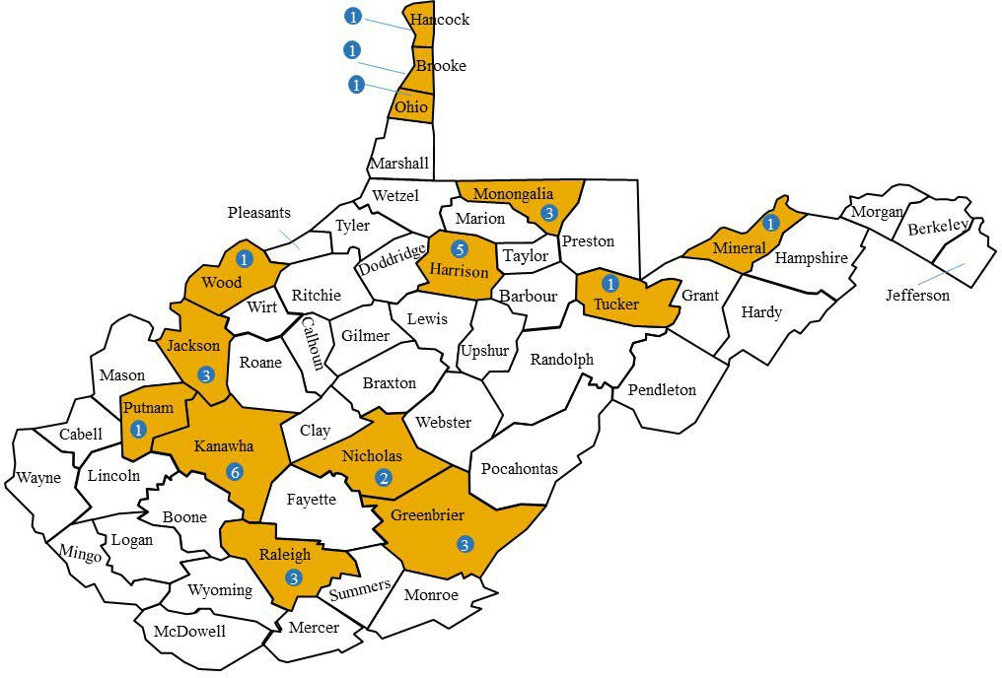

Out of State Enrollees- Home States
Country of Residence
Kuwait (1)
Lebanon (1)

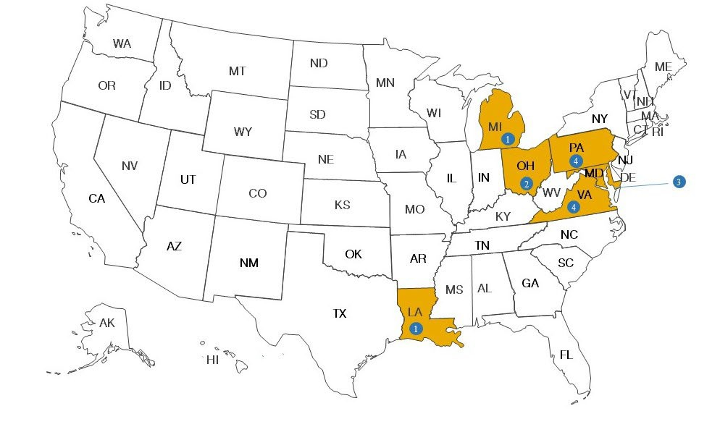
Office of Dental Admissions and Recruitment
Contact Us

dentistry.wvu.edu
Robert C. Byrd Health Science Center 1 Medical Center Drive, P.O. Box 9407 Morgantown, WV 26506-9407
Phone: 304-293-6646
Email: dentaladmit@hsc.wvu.edu

